Establishment of the University of Technology, Jamaica
Society of Manufacturing Engineers (SME) Student Chapter S430

The Member Council of the Head Quarter of the Society of Manufacturing Engineers on the 4th of November 2017 by unanimous decision approved the application to open the UTECH JA SME Student Chapter S430 with the Greater Charleston SME Chapter 430, South Carolina USA as the sponsoring chapter.

This is the third international chapter and the second English Speaking chapter Student established in the Caribbean as indicated on the SME website for international chapters. The other Caribbean SME chapters are in Trinidad and Dominican Republic respectively.

The Greater Charleston SME Chapter is providing support and mentorship for the continuous growth and development of the chapter. The Greater Charleston SME Chapter 430 has received five (5) consecutive platinum award from SME headquarters.

The UTech current membership is twenty-four (24) students excluding three engineering staff members. The Faculty members are Mr. Junior Bennett, CMfgE, Miss Tara-sue Rhoden and Mr. Shanroy Dennis. The membership is primarily industrial and mechanical engineering students currently, however the membership will be extended to include all engineering disciplines as well as students pursuing degrees in the School of Computing and Information Technology (SCIT). Students who have an interest in advancing their knowledge and extending their professional network in robotics, simulation, 3-D printing technology are also welcome to join the society. Students pursuing degrees in Industrial Technology and Construction management can become members.

Mr. Steven Mathison is the chair of the Student chapter, he is a third year Industrial Engineering student. He is ably supported by his executive team including two (2) vice presidents Comardo Roofe and Adrian Richards, Treasurer Schneider McLaughlin and Secretary Andrew Lowe. These students are third year Industrial Engineering student.

On the 30th of November 2017, the UTECH JA SME Student Chapter S430 in collaboration with the Greater Charleston SME Chapter 430 hosted a successful 3-D Printing Technology Seminar with key note speaker Kevin Hunter, the other three (3) speakers were Dick Tiano, Steven Mathison and, Junior Bennett,. There were a total of one-hundred and eight (108) persons in attendance for the seminar from various organizations and schools. The audience included faculty members, tertiary students, high school students and engineers.

The Mission of the UTech SME Student Chapter is “To drive the development of Industrial Engineering and Mechanical Engineering profession through partnership with local, regional and international manufacturing companies, service industries and engineering societies.”

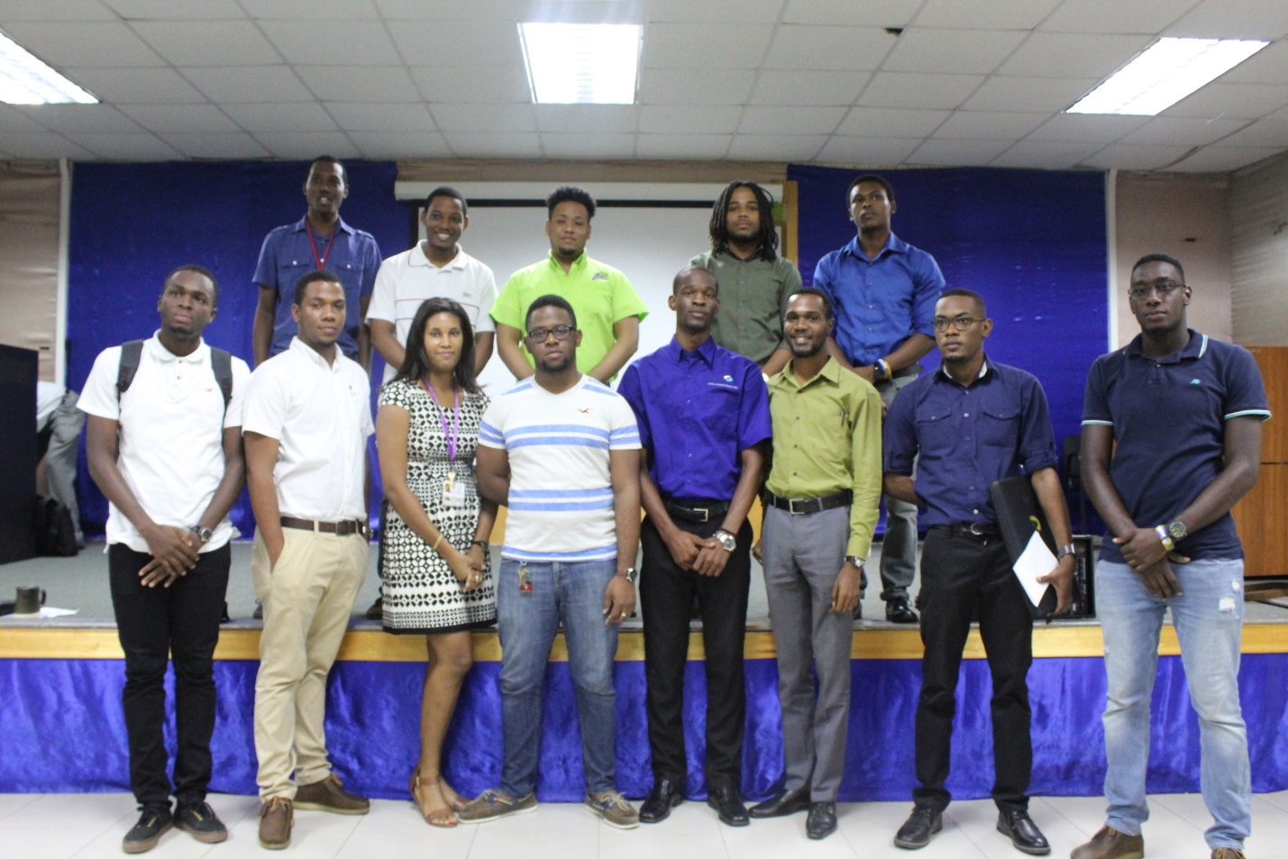

Chair Steven Mathison, Fifth Front row (Left to Right), Faculty Member Tara-sue Rhoden (Third)

Faculty Advisor Junior Bennett (Left) and Chair Steven Mathison, (Right)

